***Project Design Phase 2***

|  |  |
| --- | --- |
| Date | **5/11/2022** |
| Team ID | **PNT2022TMID43723** |
| Project Name | **Project – Natural Disaster Intensity Analysis and Classification Using Artificial Intelligence** |
| Maximum Marks | 4 Marks |

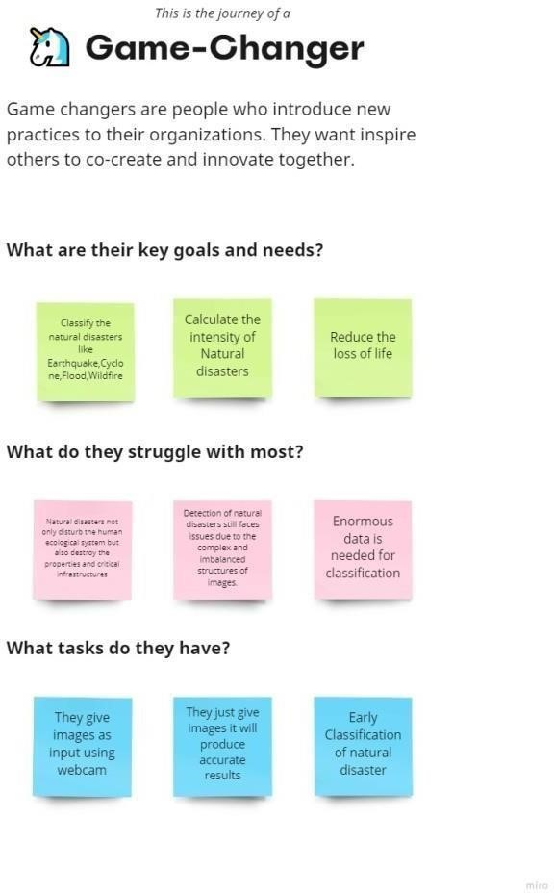 ***Customer Journey Map***

**Customer Journey Map for “Natural Disaster Intensity Analysis and Classification Using Artificial Intelligence”:**

**Step-1: Goals and needs**

**Step 2: Journey Steps**

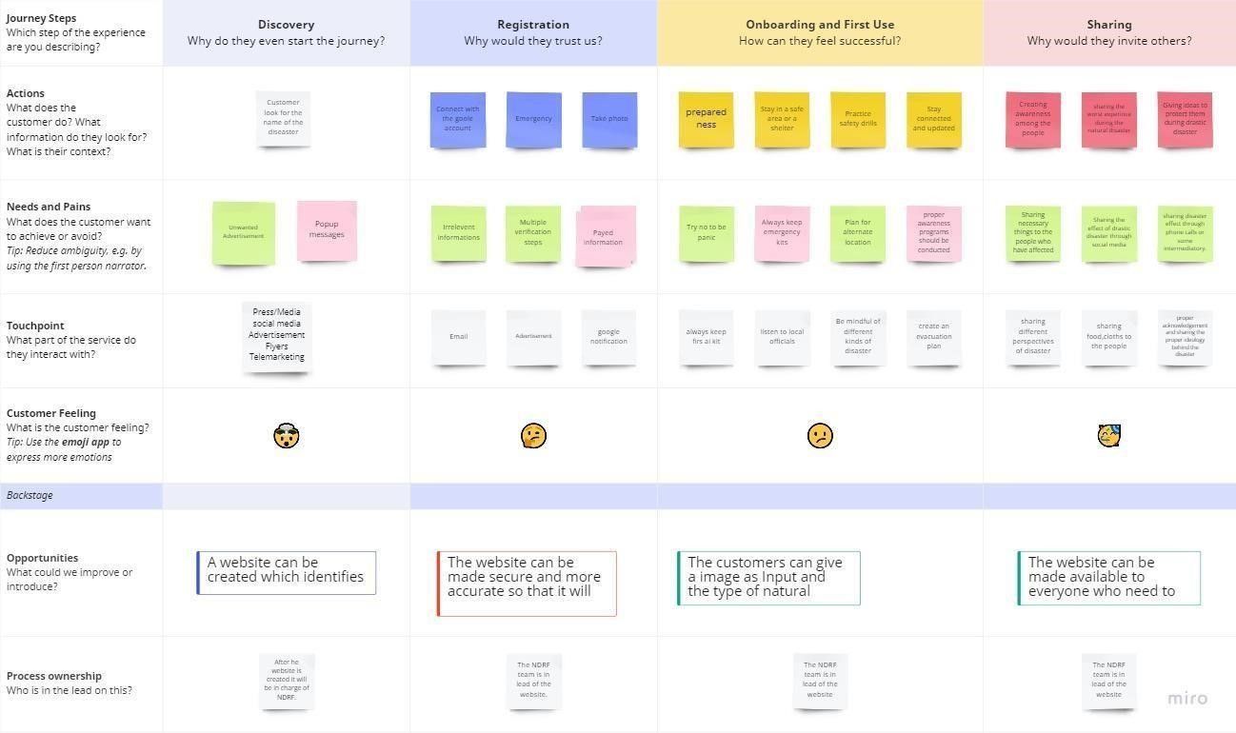

**Step 3: Journey Outcomes**

